Laparoscopic Suturing Course

25th March 2019

Teaching and learning Centre

Queen Elizabeth University Hospital

Glasgow G51 4TF

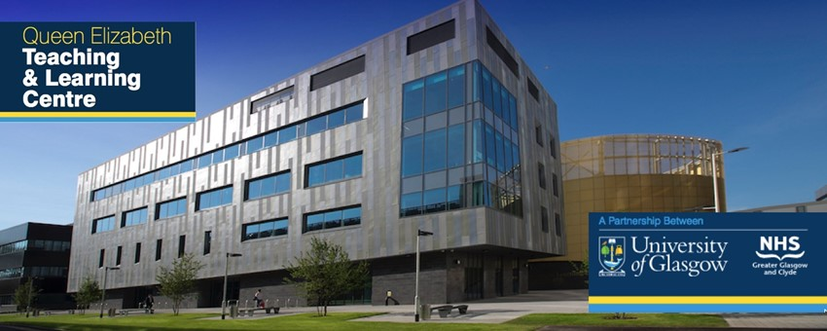

This one day laparoscopic Suturing practical course provide laparoscopic simulation based practise of advanced laparoscopic suturing skills using models. The course is designed for registrars and consultants who wish to refine their laparoscopic suturing techniques.

The course will be guided by experienced faculty. It will cover port placement for lap suturing, effective needle handling and placement of both curved and straight needles, interrupted and continuous suturing, passing needle through tissues, intracorporeal and extracorporeal laparoscopic knot techniques.

**Faculty:**

Veenu Tyagi Mohammed Allam

Karen Guerrero

**Fees and Registration:**

The course fees is £200. Cheque made payable to “Urogynaecology Research Fund”. Limited spaces available. For any querries and to register for the course please contact [Veenu.Tyagi@ggc.scot.nhs.uk](mailto:Veenu.Tyagi@ggc.scot.nhs.uk)

Please fill in the registration form below and send to **Mhairi Carruth** on address below.

Administration Corridor first floor

1345 Govan Road

Maternity Building

Queen Elizabeth University Hospital, G51 4TF

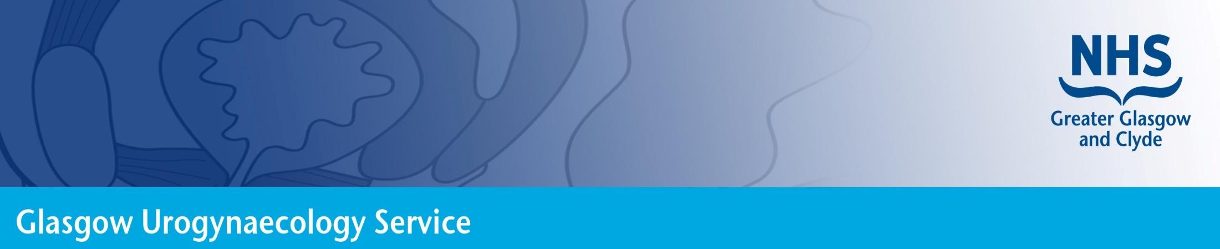

Laparoscopic Suturing Course

Glasgow March 2019

|  |  |  |
| --- | --- | --- |
| Your Details | | |
| Title | First name | Last name |
| Department | | Hospital |
| Address for correspondence | | |
|  | | |
| Postcode | | Telephone |
| Email | | Job title |
| GMC number | | Special dietary requirements |

|  |
| --- |
| Your booking ✓  |
| Please register me to attend the Laparoscopic suturing Course at a cost of £200 |  |