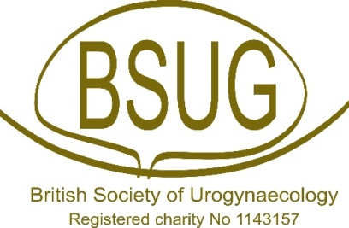
Name:
Address:
Hospital Number:
DoB:
COVID-19 Specific Consent Form
General
- The alternatives to the procedure I am attending for have been discussed with me, as have the risks of not proceeding with the procedure which could include a worse outcome from the underlying disease
- I have been warned that attending hospital might increase my risk of catching COVID-19
- I have been warned that if I do catch COVID-19, it may make my recovery from my procedure more difficult, it may increase my risk of serious illness or even death
- I have been warned that if I need critical care during my stay I might be moved to another hospital
- It has been explained that it is likely that I will not be able to have friends and family visit me whilst in hospital.
Specific
- I have not experienced any COVID-19 symptoms during the self-isolation period.
- I confirm that I have been self-isolating for the number of days requested by my hospital.
- No members of my household or other contacts have been unwell with COVID-19 symptoms during the self-isolation period.
- I have undergone COVID-19 swab testing and understand that I have tested negative for COVID-19.
Patient
Signature ………………………………………………..
Name (PRINT) ………………………………………….. Date ……………………
Clinician
Signature …………………………………………………
Name (PRINT) …………………………………......... Date …………………………….

